MedBook

Software Development Plan

Version 1.2

Revision History

|  |  |  |  |
| --- | --- | --- | --- |
| **Date** | **Version** | **Description** | **Author** |
| 29/10/21 | 1.0 | Complete section 1, 2, 3, 4.1, 4.2, 4.3.1, 4.3.3 | NPVy, NNDu, NKTTNga |
| 12/11/21 | 1.1 | Complete section 4.3.2 | NNDu |
| 26/11/21 | 1.2 | Edit section 4 | NPVy |
|  |  |  |  |

Table of Contents

**1. Introduction 4**

**2. Project Overview 4**

**2.1 Project Purpose, Scope, and Objectives 4**

**2.2 Assumptions and Constraints 4**

**2.3 Project Deliverables 4**

**3. Project Organization 4**

**3.1 Organizational Structure 4**

**3.2 Roles and Responsibilities 5**

**4. Management Process 5**

**4.1 Project Estimates 5**

**4.2 Project Plan 5**

**4.2.1 Phase and Iteration Plan 5**

**4.2.2 Releases 5**

**4.2.3 Project Schedule 6**

**4.3 Project Monitoring and Control 7**

**4.3.1 Reporting 7**

**4.3.2 Risk Management 8**

**4.3.3 Configuration Management 8**

Software Development Plan

# Introduction

This Software Development Plan will define the development activities for developing the MedBook App. Every detail of the development, test and deployment process will be covered in this document.

# Project Overview

## Project Purpose, Scope, and Objectives

Purpose: The primary goal of this project is to create an application that helps people to make an appointment with their doctors along with some convenient features.

Scope: This project is meant to reach out to everyone and every class of society.

Objectives: Create a fully functional application for making appointments and checking health for patients and doctors.

## Assumptions and Constraints

* The project has a fixed schedule of 10 weeks.
* Zero-budget project.
* The project has 5 people, there will be no more people added during the project.
* Android test only.

## Project Deliverables

Deliverables of the project are identified in the project schedule. Deliverables include:

* Vision Document
* Software Development Plan
* Use-case Specification Document
* Software Architecture Document
* Test cases and reports
* Weekly Report
* Database Design
* Source code (UI and Backend Implementation)

# Project Organization

## Organizational Structure

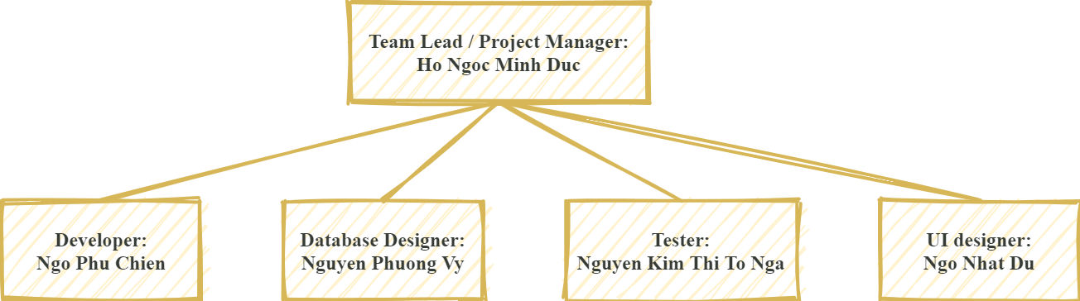

## Roles and Responsibilities

|  |  |
| --- | --- |
| ***Person*** | ***Role*** |
| **Hồ Ngọc Minh Đức**  **Ngô Phú Chiến**  **Nguyễn Phương Vy**  **Ngô Nhật Du**  **Nguyễn Kim Thị Tố Nga** | *Project manager*  *Developer*  *Database designer*  *UI designer*  *Tester* |

# Management Process

## Project Estimates

Project Time: 10 weeks ( 5 sprints)

Members: 5 people

## Project Plan

### **Phase and Iteration Plan**

|  |  |  |  |
| --- | --- | --- | --- |
| **Phase** | **Iteration** | **Objectives** | **Milestones** |
| Inception | Sprint 1 | Define the scope of project, business use-case, product requirements. Draw up the project plan and make a description of the project goal, risks, and business model. | Scope and business case agreement |
| Elaboration | Sprint 2 | Analysis, design use-case models, and specify the structure of each model. | Use-case model |
| Sprint 3 | Complete use-case specification and establish product prototype architecture. | Baselined architectural prototype. |
| Construction | Sprint 4 | Revise Software Architecture.  Design UI for the software system, implement and test M1 version. | M1 version |
| Sprint 5 | Fixing the previous version and complete implementation.  Test plan and test case. | M2 version |

### 

### **Releases**

**Sprint 1 (30/10/2021):**

* Business cases of project , Vision Document and Software Development Plan Document

**Sprint 2 (13/11/2021):**

* Vision Document, Software Development Plan Document, User Specification Document (contains use case-model)

**Sprint 3 (27/11/2021):**

* User Specification Document, Software Architecture Document, Database structure and UI for main screens.

**Sprint 4 (11/12/2021):**

* **M1 (MedBook version 1)** contains most of basic functions as below:
* Admin’s features
* Sign in and Sign up
* Set up/Manage appointment schedule
* Review appointment history and medical information
* Searching hospital’s and doctor’s information
* Notification

**Sprint 5 (2511/12/2021):**

* **M2 (MedBook version 2)** should have these features including:
* Discount
* Pay for treatment
* Human Resources Management

Some additional features may be implemented like:

* Update medical news
* Private Chat
* Donation

### **Project Schedule**

**Link for Project Plan**:

<https://drive.google.com/file/d/1Sb6FKOBxH0465Ahe9ZfNd3f1mkBcKAY_/view?usp=sharing>

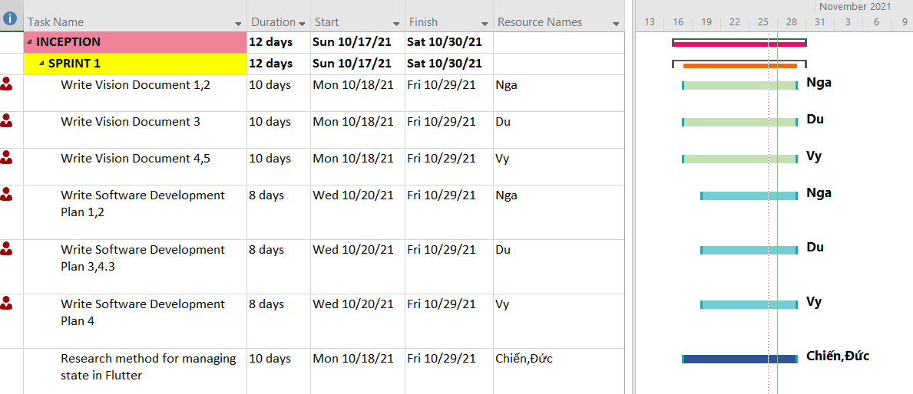

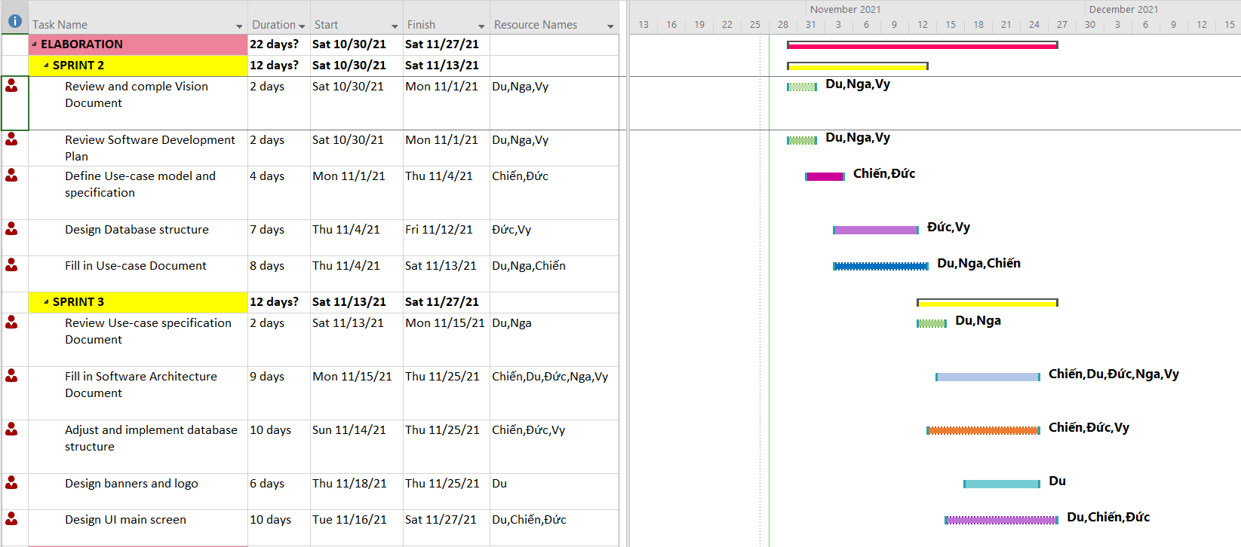

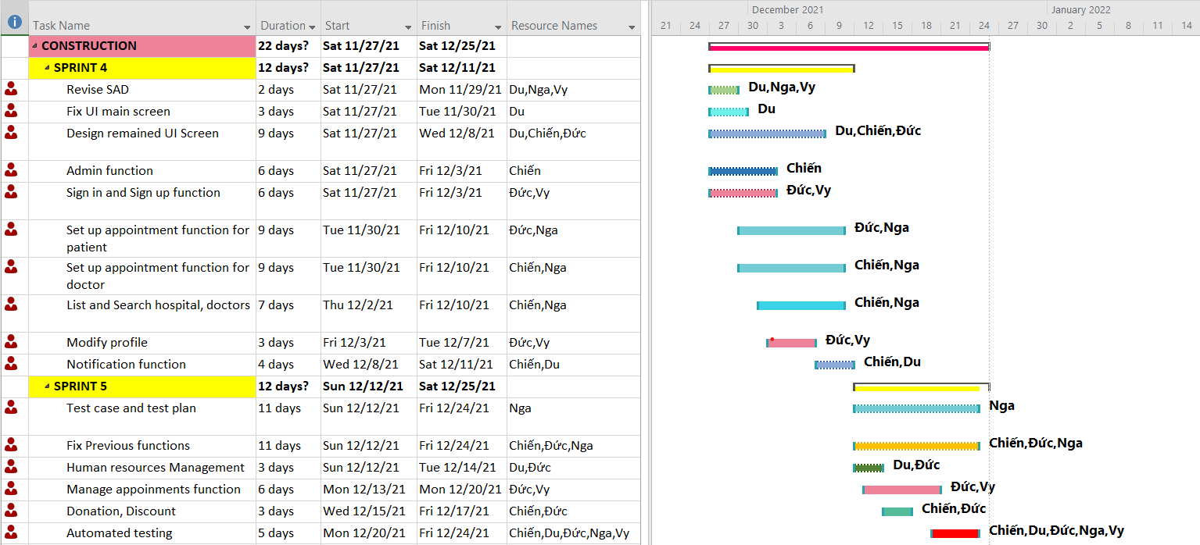

## Project Monitoring and Control

### **Reporting**

Weekly meeting via Zoom every Tuesday and every other Friday.

Weekly status report on Google Drive: update at every meeting.

Informal chats via Facebook Messenger group chat.

### **Risk Management**

|  |  |  |  |  |  |
| --- | --- | --- | --- | --- | --- |
| ***Risk ID*** | ***Risk Description*** | ***Probability*** | ***Impact*** | ***Priority*** | ***Mitigation Strategy or Contingency Plan*** |
| 1 | Software technical problem | 6/10 | 9/10 | High | - Punctuated software updates in order to fix the situation. |
| 2 | Data loss | 5/10 | 8/10 | High | - Inform other members, relocate the lost information.  - Reupdate information to the software. |
| 3 | Low performance | 3/10 | 5/10 | High | - Accelerate and optimize performance, especially in the designing and analyzing phase. |
| 4 | Information leakage | 3/10 | 7/10 | Medium | - Enhance privacy security. |
| 5 | Overdue deadlines | 2/10 | 6/10 | Medium | - Prioritize punctuation to meet the deadlines’ requirements on time and not to affect other members’ schedules. |

### **Configuration Management**

Google Drive for storing and shuttering documents and files.

GitHub for managing code and related files.